**Year 2 – Autumn Curriculum Letter**

Welcome back to St. Mary’s for the Autumn Term. I hope you had an enjoyable and restful Summer break. This letter will inform you of the exciting things that your child will be learning about over the next term.

**General reminders**

Please ensure that your child reads every day and that this is noted in your child’s home-school diary. Children’s reading should be noted in the home-school diary at least 4 times a week. If there are any important notes, especially regarding a change in pick-up arrangements, please ensure that these notes are clearly written in the home-school diary.

Please ensure your child has the correct uniform every day and that all of your child’s belongings are clearly name-labelled.

Our PE days (for the first half term, at least) are Thursday and Friday. Please ensure your child come to school in their PE kit on these days and if they have an after (or before) school club. Please ensure earrings and watched are removed on the P.E days.

Handwriting and times-tables will be collected and given out on Fridays. Children should practice these every day, for no more than 10 minutes. There might be the occasional maths worksheets to complete at home. This will be handed out on a Friday and be due in the following week.

**Curriculum**

**RE**

Our topics for RE this half term are ‘Beginning: God at every beginning’ and ‘Belonging: Signs and symbols’.

|  |  |  |  |  |
| --- | --- | --- | --- | --- |
| **Beginning: God at every beginning**  **Learning objectives** | | | | |
| God was there at the beginning of the world. | God was there at my beginning and god is there at every beginning. | It is good to begin the day with prayer. | Psalm 19 is a song of praise to God. God is always close. | God, who is present in our beginning, knows and loves each one. |

|  |  |  |  |  |  |
| --- | --- | --- | --- | --- | --- |
| **Belonging: Signs and symbols**  **Learning objectives** | | | | | |
| Review the Sacrament of Baptism. | Signs and symbols: the welcome. | Signs and symbols: baptism with water. | Signs and Symbols: anointing with the oil of Chrism. | Signs and symbols: the white garment. | Signs and symbols: The Baptismal candle. |

**Maths**

Our areas for study for this term are Place Value, ‘Addition and Subtraction’ and Shape. Children will develop their fluency, reasoning and problem-solving skills in these areas.

|  |  |  |
| --- | --- | --- |
| **Place Value** | **Addition and Subtraction** | **Shape** |
| Numbers to 20  Count objects to 100 by making 10s  Recognise tens and ones  Use a place value chart  Partition numbers to 100  Write numbers to 100 in words  Flexibly partition numbers to 100  Write numbers to 100 in expanded form  Place 10s and 1s on the number line to 100  Estimate numbers on a number line  Compare objects and numbers  Order objects and numbers  Count in 2s, 5s and 10s  Count in 3s | Bonds to 10  Fact families – bonds within 20  Related facts  Bonds to 100 (tens)  Add and subtract 1s  Add by making 10  Add three 1-digit numbers  Add to the next 10  Add across a 10  Subtract across 10  Subtract a 1-digit number from a 2-digit number (across a 10)  10 more and 10 less  Add and subtract 10s  Add two 2-digit numbers  Subtract two 2-digit numbers  Mixed addition and subtraction  Compare number sentences  Missing number problems | Recognise 2-D and 3-D shapes  Count sides on 2-D shapes  Count vertices on 2-D shapes  Draw 2-D shapes  Lines of symmetry on shapes  Use lines of symmetry to complete shapes  Sort 2-D shapes  Count faces on 3-D shapes  Count edges on 3-D shapes  Count vertices on 3-D shapes  Sort 3-D shapes  Make patterns with 2-D and 3-D shapes. |

Children will continue to be tested on their multiplication tables weekly. Regular practise is important and has a positive impact on Maths attainment.

**English**

Children will continue to develop their reading and writing skills through study of our class texts. Children will develop a greater understanding and mastery of spelling, grammar and punctuation.

Children will read with an adult on a weekly basis, and will further develop their reading skills in Reading lessons, but we still recommend children read for at least 20 minutes every day with an adult.

|  |  |
| --- | --- |
| **Reading**  **Learning focuses** | **Writing (inc. SPAG)**  **Learning focuses** |
| Draw inferences from reading.  Predict from details stated and implied.  Explain and discuss understanding of reading, maintaining focus on the topic.  Identify how language, structure and presentation contribute to meaning.  Ask questions to improve understanding of a text.  Identify main ideas drawn from more than one paragraph and summarise these. | Write simple, coherent narratives about personal experiences and those of others (real or fictional).  Write about real events, recording these simply and clearly.  Demarcate most sentences in their writing with capital letters and full stops, and use question marks correctly when required.  Use present and past tense mostly correctly and consistently.  Use co-ordination (e.g. or / and / but) and some subordination (e.g. when / if / that / because) to join clauses.  Segment spoken words into phonemes and represent these by graphemes, spelling many of these words correctly and making phonically-plausible attempts at others.  Spell many common exception words.  Form capital letters and digits of the correct size, orientation and relationship to one another and to lower-case letters.  Use spacing between words that reflects the size of the letters. |

**Science**

Our topics for this term are ‘Living things and their habitats’ and ‘Animals, including humans’.

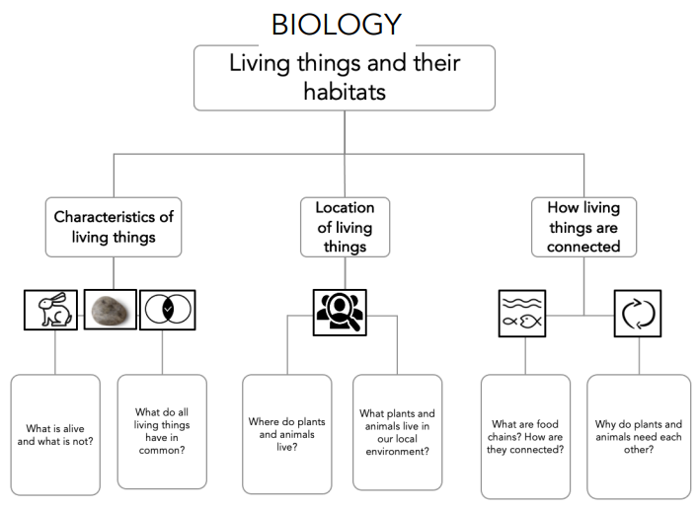

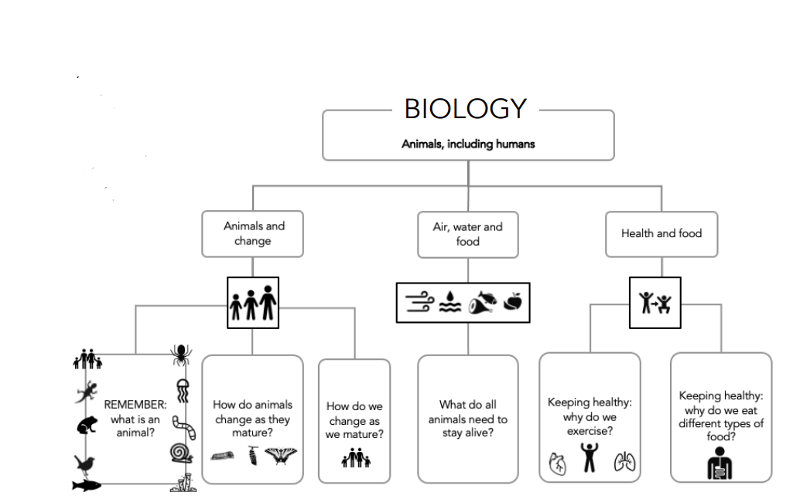

Children will continue to develop their ‘Working Scientifically’ skills by planning, designing, undertaking and evaluating their own investigations.

**Geography**

Our topics for this term are ‘Human and Physical features’ and ‘Compare a small part of the UK to a non-European location – London and Nairobi’.

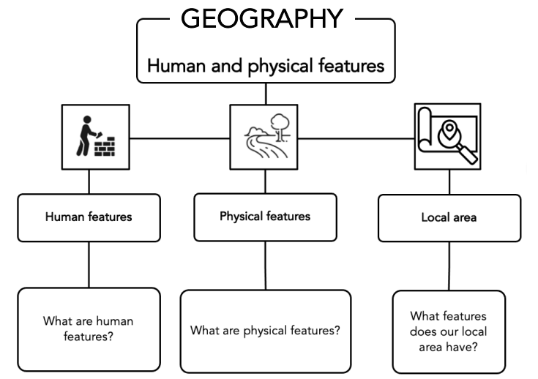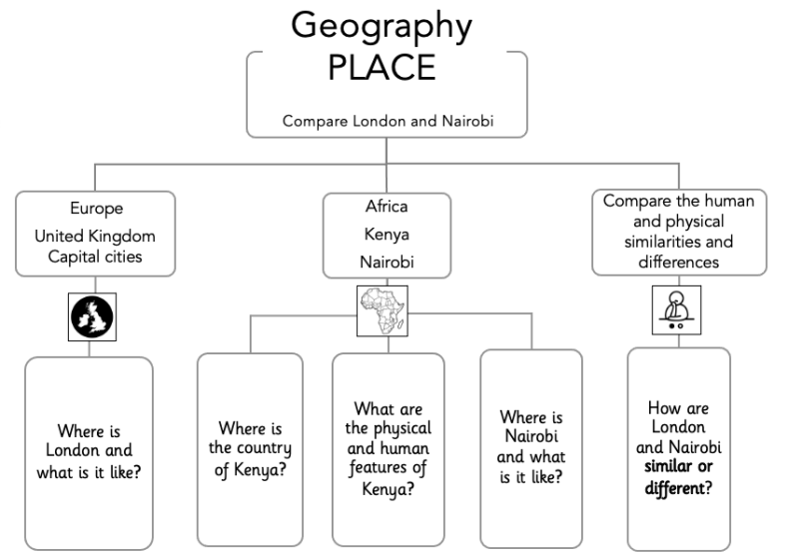

**History**

Our topic for the term is ‘Events beyond living memory: The Great Fire of London’.

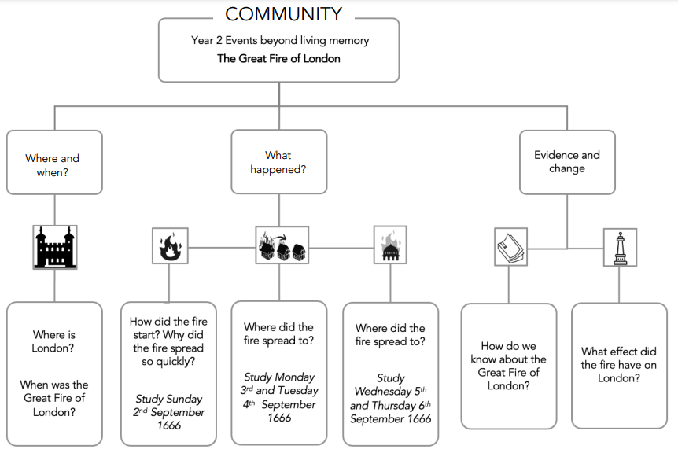

**Computing**

Our topic for Computing this term is ‘Creating Media: Digital Music’.

|  |  |  |  |  |  |
| --- | --- | --- | --- | --- | --- |
| **Creating Media: Digital Music**  **Learning objectives** | | | | | |
| How music makes us feel | Rhythms and patterns | How music can be used | Notes and tempo | Creating digital music | Reviewing and editing music |

**PSHE/RSE**

This term we will look at healthy lifestyles, growing and changing, and keeping safe.

Our RSE unit is called ‘Created and Loved by God’.

**Art**

Our topics for the term are ‘Drawing’ and ‘Painting’.

|  |  |
| --- | --- |
| **Drawing** | **Painting** |
|  |  |

**DT**

Our topics for this term are Textiles and ‘Food and Nutrition’.

|  |  |
| --- | --- |
| **Textiles** | **Food and Nutrition** |
|  |  |

**PE**

Our focus for this term is on honing our skills in games and gymnastics. PE will be taught by Mrs Dyer on Thursdays and Miss Maskery/Mr Hurd on Fridays.

**Music**

Music will be taught by Mrs Dyer on Thursday mornings.

**I look forward to working closely with you over the term.**

**Should there be any questions or problems, do not hesitate to make an appointment to see me.**

**With very best wishes,**

**Miss Maskery**