**Friends of St Mary’s (FOSM) 2024/25 – Who’s who?**

There is nothing like putting a face to a name so here is a overview of our committee. Please say hello when you see us!

Our Committee:

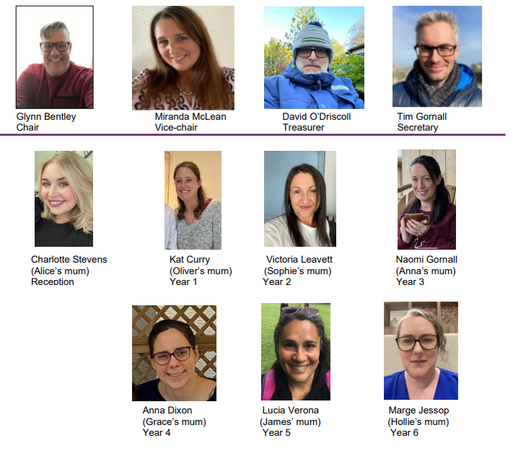

Our Class Reps:



Occasional volunteers: we have an extremely valuable group of occasional volunteers, who get first sight of any opportunities to help the PTA and share their thoughts and opinions. There is no pressure, you just volunteer for the things that appeal to you.

If you would like to be part of this WhatsApp group, have fundraising ideas, suggestions, or can help in any way, please contact Glynn at [friends.of@st-marys-ipswich.suffolk.sch.uk](mailto:friends.of@st-marys-ipswich.suffolk.sch.uk) or via the school office. Thank you.